The Lascaux cave / Lascaux 2
Rick Steves
https://www.youtube.com/watch?v=rVBKFzrdt6M

When does the Lascaux caves date back to?

Long before what?

Find these words, phrases, sentences in the video:
(NB: saber-toothed cat 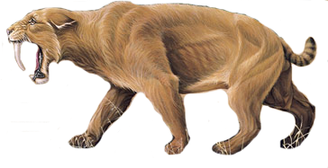)

C’était quand les mammouths et les lions des cavernes parcouraient encore la terre :

Gribouillage grossier / rudimentaire :
Les madgaléniens :
Des falaises de calcaire alvéolées de grottes ornées :

When and how were the caves discovered?

How did the tourists damage the Lascaux cave?

In just _____ years the precious art deteriorated more than in the ______ years before that.

How can now the tourists enjoy the wonder of Lascaux?

Name of the most spectacular room of Lascaux?

How do you say ‘lieu sacré’?

What are the three principal animals of Lascaux?

Is it a hunting scene?

What is the biggest animal? How big is it?

Convert 16 feet in metres:
How many aminals are painted?

National museum of prehistory
First look up these words:
A stag: , to drill: , to string (strung, strung)
Barbed: , A spearhead: , a fish hook: , spear thrower:
Oil lamp:

The museum provides ____ _____________ ___________________
This modern museum ______________ over _________________ bones, stones, and fascinating little doodads all ______________ locally.
_________________ are original.
_______________ were draped in delicate jewelry.
________ ____________ and ___________ ____________ were lovely _____________ to be _____________ into _________________.
These _______________ ______________________ and ______________ would work well today.
Finely ____________ spear thrower.

